**Business Problem**

In recent years, City Hotel and Resort Hotel have seen higher cancellation rates. Each hotel is now dealing with a number of issues, as a result including, less revenue, also facing lower ideal number of room usage. Consequently, lowering the cancellation rates is the primary goal for both the hotel types (city hotel, resort hotel), in order to increase their efficiency in generating revenue and for us to offer thorough business advice to address this problem.

The analysis of hotel booking cancellation, as well as other factors that have no bearing on their business and yearly revenue generations are the main topics of this report.



**Assumptions**

1. No unusual occurrences(extreme values/outliers) between 2015 and 2017 will have a substantial impact on the data used.
2. The information is still current and can be used to analyse the hotel’s possible plans in an efficient manner.
3. There are no unanticipated negatives to the hotel employing any advised technique.
4. The hotels are not currently using any of the suggested solutions.
5. The biggest factor affecting the effectiveness of earning income is booking cancellations.
6. Cancellations result in vacant rooms for the booked length of time.
7. Clients make hotel reservations the same year they make cancellations.

**Research Questions**

1. What are the variables that affect hotel reservation cancellations?
2. How can we make hotel cancellations lower?
3. How can hotels be assisted in making pricing and promotional decisions?

**Hypothesis**

1. More cancellations occur when prices are higher.
2. When there is longer waiting list, customers tend to cancel more frequently.
3. The majority of clients are coming from an offline travel agents to make their reservations.

**Analysis and Findings**

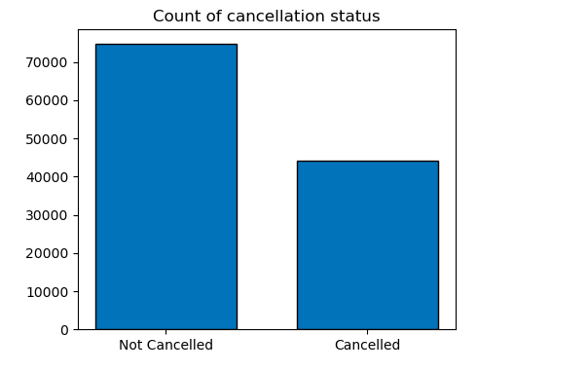

The accompanying bar graph shows the count of reservations that are cancelled and those that are not cancelled. It is obvious that there is significant number of rooms that are not cancelled. However, the cancelled count is also higher, although the cancelled count is less than the not cancelled, but still, the cancelled count are more and about 37% of clients have cancelled their reservations, which has a significant impact on hotels’ earnings.

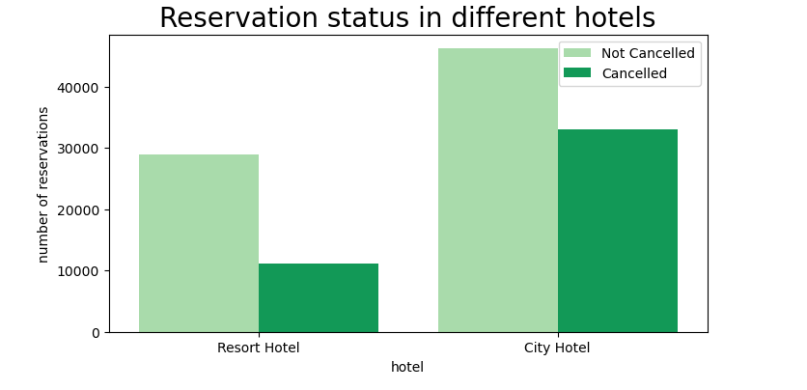

In comparison to Resort Hotels, City Hotels have more bookings, It is possible that Resort Hotels are more expensive than that of City Hotels.

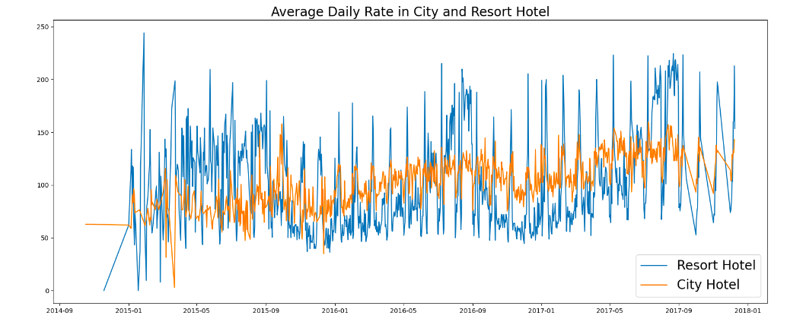

The line graph above shows that, on certain days, the average daily rate for a city hotel is less than that of a resort hotel, and on other days, it is even less. It goes without saying that weekends and holidays may see a rise in Resort hotel rates.

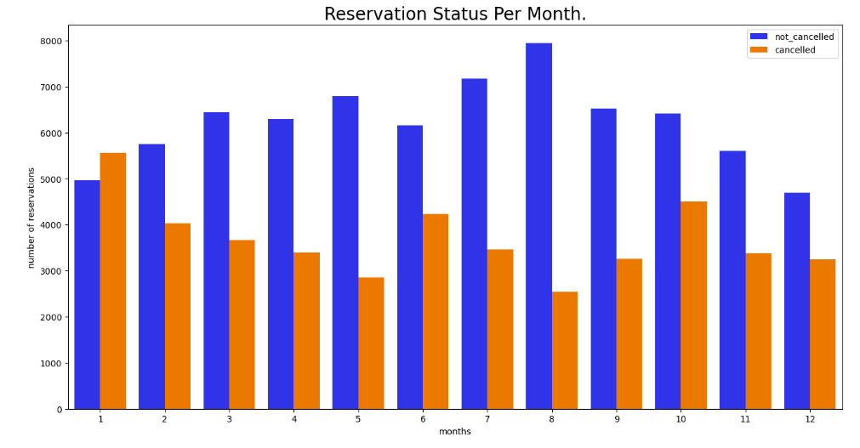

From the above graph it is clear that more reservations happened in the month of August, we can also observe that in the same month there were less cancellations.

We can also see a majority of cancellations happened in the month of January, also the number of reservations are less in January compared to other months.

This higher cancellations in one month and higher reservations in other month can be due to higher hotel rates.

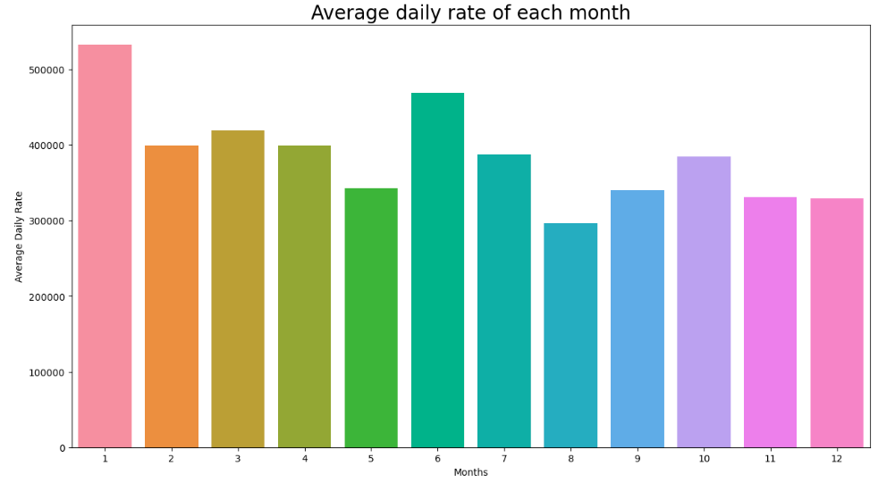

From the above graph we are sure of the fact that the Average daily rate I.e. the price of the hotel was lower in the month of August which resulted in higher reservations and less cancellations.

Whereas, the ADR was highest in the month of January which had resulted in less number of reservations and comparatively higher number of cancellations.

Therefore, the cost of hotel is solely responsible for cancellations.

*Now let’s see which country has the highest cancellation rates.*

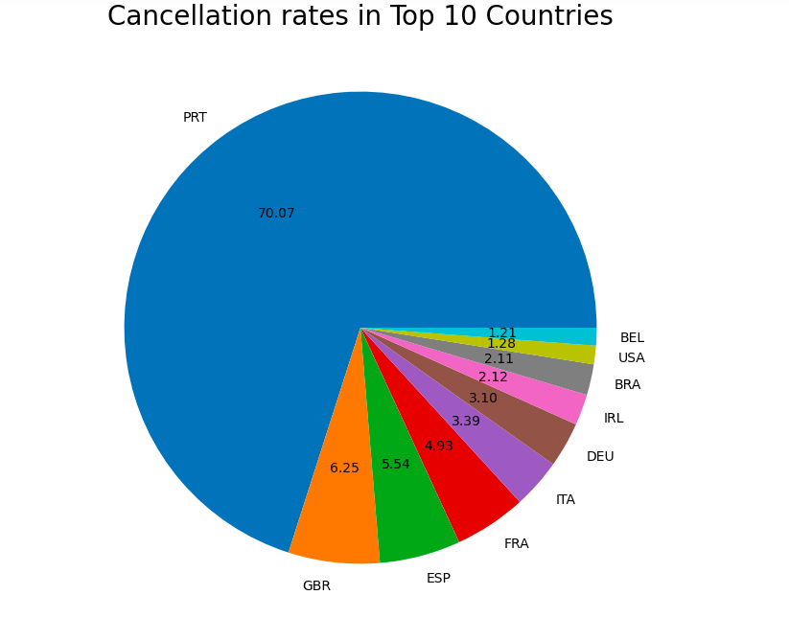

From the above visualization, it is clear that Portugal has the highest cancellation rate among the other group of countries.

*Now let’s see from where are the majority of clients coming? Are they coming from Online travel agent or from an offline one?*

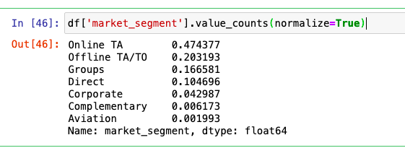

* Around 47% of the clients come from online travel agencies.
* Around 20% come from offline travel agents. Only around 10% of the clients book hotels directly by visiting.

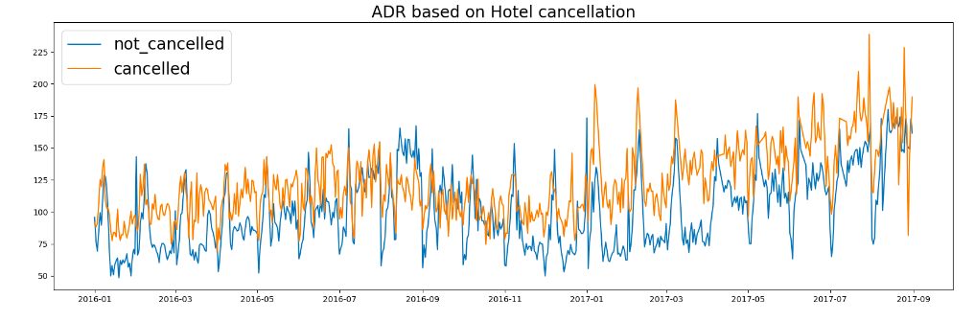

As seen in the graph, reservation are cancelled when the average daily rate is higher than when it is not cancelled. It clearly proves all the above analysis that **higher prices leads to higher cancellations**.

**Suggestions**

1. Cancellation rates rise as the price does. In order to prevent cancellations of reservations, hotels could work on their pricing strategies and try to lower rates for specific hotels based on locations, include offers and discounts when the price needs to rise up.
2. In the month of January hotels can start marketing campaign to increase or protect their revenues as the cancellation rates are higher in this month.
3. Hotels needs to improve their quality and services or even lower the rates in Portugal, as the cancellation rate is higher in this country.
4. As the ratio of cancellation and not cancellation of the resort hotel is higher in the resort hotel than the city hotels. So, hotels should provide reasonable discounts to the room prices on weekends and also on holidays.